شماره مجوز مجله:80400 زمان پذیرش نهایی:25/12/99

Design of high-rise concrete buildings

Author Name : Nazanin Zandi Ali Abadi ¹*
1-Academic rank: BS student in Civil Engineering, Faculty of Engineering, Islamic Azad University, North Tehran Branch Tehran Iran
Email: nzninzndi@gmail.com
Fall 1399

Digest
For many years, concrete has been used as an important building material with high pressure tolerance for the construction of various structures. The weakness of this important and widely used building material against traction has been largely compensated by placing reinforcement. In recent years, with the study of durability of reinforced concrete structures, especially in corrosive and hard areas for concrete, the opinion of most experts and those involved in concrete work has been drawn to the fact that strength alone can not meet all the properties of concrete, especially its durability. In addition to the issue of strength and load bearing during operation (exploitatiom), its durability and permanence should be considered in the design of concrete for different areas.
Now with the addition of various concrete materials and modifications
In the mixing design, concretes can be obtained that do not significantly change their strength in terms of durability to achieve high durability concretes. The issue of the environment and its pollution has also attracted the attention of the world in recent years. The use of substances and materials in the construction of which less pollution is transferred to the environment and also the harvesting of natural materials that are less.
Destructive to the environment, special attention is paid. In this regard, the use of aggregates, access to new materials and
Also, the use of factory wastes and environmental pollutants in concrete is located at the top of research programs in some countries of The world. in addition to concrete itself and its constituent materials, in recent years, changes have been made on the reinforcement used in reinforced concrete structures. For example, to avoid the risk of corrosion of the reinforcement, stainless steel as well as reinforcements made of different plastic and polymer fibers are used in highly corrosive environments.
Keywords: tall buildings, steel, structural forms, high strength concrete, structural stability
Prelude
In each of the specialized areas related to the building, a different definition of a high-rise building is provided. M) From an architectural point of view, a building with a height-to-diameter ratio of at least 3.14 is considered tall. From a fire point of view, it is a tall building whose upper floors are not accessible to an ordinary fire engine.
Accordingly, in Iran, any building with a height of more than 23 meters is considered tall (tall buildings in Iran, according to the rules and regulations of the Supreme Council of Architecture and Urban Planning approved in 1998, are called buildings above six floors. According to some views, the definition of a tall building in Tehran can be such that if a building has one of the following two conditions, it can be considered as a tall buil
1.Height more than twelve floors, which can be considered as an urban landmark
2. Visible impact on the skyline of the city

High-strength concrete (high-strength concrete) or HSC
High-strength concrete or high-strength concrete (HSC) is concrete made of ordinary aggregates with a compressive strength of more than 40 MPa.
The strength of ordinary concrete is between 21 and 40 MPa. For the production of concrete with a strength of more than 40 MPa, more precise quality control is needed, as well as more accuracy in the selection of materials and their ratios (lubricants, mineral additives, type and size of aggregates, etc...)
Therefore, to distinguish this type of special concrete, which has a compressive strength of more than 40 MPa, compared to conventional concrete, they are called high-strength concrete
To increase the strength of concrete, the ratio of water to cement should be less. Doing so prevents some of the cement grains from being hydrated. These granules increase the density and increase the strength of concrete.
In addition to reducing water consumption, the amount of soliman should be reduced and instead pozzolanic materials such as fly ash, silica fume and smelting iron slag slag should be added to it. As the strength of concrete increases, the probability of its fragility and cracking increases, so to soften the concrete, short fibers can be used in its construction.
The most important criterion for evaluating the quality of concrete is its compressive strength. The strength of concrete depends on its density.
Accordingly, the flow rate of the mixture should be such that a suitable density can be achieved. Lack of compaction in concrete reduces the strength of concrete and causes cracking in it, and the connection between rebar and concrete is not complete.
If materials such as superplasticizers and microsilica are used in the right amount in the mixture, a high density mixture will be produced.

common ratios of high strength concrete ingredients

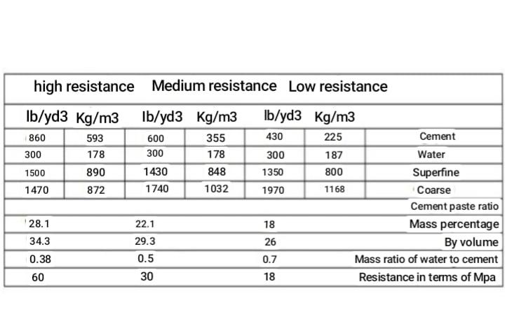
*The resistances listed in the tables are measured from a 15×30 cm cylindrical specimen at the age of 28 with standard processing

One of the most important things in the life and durability of concrete,is to pay attention to climatic conditions, temperature and cold. In fact, the conditions of concrete construction make its inevitability from its climatic conditions, especially temperature, inevitable, and since the ambient temperature is always a function of time and place, so it is important to study it as a variable parameter in concrete and the effects of changes. Because concrete is made in conditions in direct contact with the environment, it is constantly affected by its climatic conditions.
Temperature is the most important climatic factor that affects concrete more than any other factor. These effects on fresh and hardened concrete are significant. Since the composition of concrete is always a matter of time management, concreting in cold weather is of particular importance.
Due to the severe cold in some parts of the country, such as Azerbaijan, concreting is usually stopped in most projects.
By implementing measures such as installing electric fan heaters inside the tunnels and using torches and heating pipes in concreting with the tunnel formwork system, it is possible to concretize in cold weather and increase the strength of concrete.
This figure shows that the most economical way to build the columns of tall buildings is to use a method in which the minimum possible amount of steel is consumed and the maximum possible strength is achieved.
The economic advantage of using high-strength concrete for columns and shear walls has been demonstrated in many structures built in Chicago, New York, Houston and other US cities. In the United States, for the past 20 years, high-strength concrete has generally been used to build 30-story or higher reinforced concrete structures.
At (3/1) high height of the building, the columns are made of ordinary concrete. But if the columns at the bottom of the building are made of ordinary concrete, the dimensions of the columns will be very large. Concrete lubricant and its role in the long life of the structure in 2009 | A substance that, without change, greatly reduces the amount of water in the concrete mix, or without changing the amount of water, greatly increases the fluidity of the concrete, or causes a large decrease in water and a large increase in the fluidity of the concrete at the same time. They are called wet lubricants or reducers.
These materials are one of the newest and most effective types of water reducers that have been named as strong lubricants in the United States.
The effect of the material is such that at higher temperatures the improvement in efficiency will be less. The resulting concrete can be poured with low density or without the need for compaction, and if the coarse concrete grains are not long, flat or very broken and the fine grains are more than 4 to 5%, the adhesion of concrete will be maintained and There will be no separation or watering. It should be noted that when designing molds, it should be borne in mind that liquid concrete can apply full hydrostatic pressure to the molds.
In the long run, the properties of concrete are not significantly affected by this type of additive. The results of long-term experiments up to 13 years that are available have shown that these materials do not have an adverse effect on the long-term strength of concrete.
The effect of high lubrication of these materials will be for a short time (maybe ten minutes) and after about 30 to 90 minutes of work will return to normal. For this reason, it is necessary to add superplasticizers to the mix just before pouring the concrete. In general, superplasticizers can reduce the amount of concrete water by 20 to 30% to achieve a certain efficiency (in the case of conventional lubricants, half of this amount is achieved) and increase the 24-hour strength of concrete by 50 to 70%. In shorter lifespans this increase will be even greater
Properties of concrete In the early moments of concrete mixing, concrete has a pasty state, and after performing operations such as pouring it into the formwork, compacting and maintaining it, it takes on time and hardens, and as a result, in the form of formwork. It comes on its own. Therefore, concrete in the life cycle, including fresh state and hardened state, must meet the expectations of the structural designer in both periods.

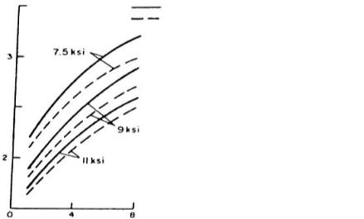

Price of ready-mixed concrete How to calculate per cubic meter of ready-mixed concrete? The price of ready-mixed concrete has been increasing recently because of the increase in the price of raw materials, which is increasing day by day. In 1998, the price of each cubic meter with a grade of 350 increased from 180 per cubic meter to 250 tomans per cubic meter.
What is ready-mixed concrete? Ready-mixed concrete is concrete that is produced in a concrete factory under standard conditions and is transported to the desired workplace by a mixer. It should also be noted that the time between production and execution should be 90 minutes, and also ready-mixed concrete is produced in two forms of dry mixing and wet mixing.
What determines the strength of concrete? Concrete is compacted after 28 days according to the compressive strength of the sample. Resistance
Concrete is usually measured in kilograms per square centimeter. The concrete grade according to its compressive strength is as follows: Ordinary concretes:
C8/10, C12/15, C16/20, C20/25, C25/30, C28/35, C30/37, C32/40,
C40/50, C50/60, C55/67, C60/75, C70/85, C90/105, C100/115

Lightweight concrete:
LC8/9, LC12/13, LC16/18, LC20/22, LC25/28, LC30/33, LC35/38,
LC40/44, LC50/55, LC55/60, LC60/66, LC70/77, LC80/88
Numbers are the amount of compressive strength (MPa=10.2 kg/cm2)
For example, C25 concrete is concrete with a compressive strength of 25Mpa or 225 kg/cm.
Weaker concrete such as bed concrete except in group C75 with compressive strength kg
275cm after 28 days. In most cases, C20 type concrete is sufficient and suitable for landscaping. This concrete is approximately equal to the ratio of the chemical mixture 4:2:1
In building engineering, concrete with very high strengths, such as type C40, can be used. Hierarchical analysis method Project managers face many decisions that create complex problems. Therefore, decision-making ability is one of the most important skills of project managers and one of the factors of project success. Multi-criteria decision making is used to select the best option from the available options according to several decision indicators. The AIIP hierarchical analysis process developed by the clock is one of the most useful practical tools for multi-criteria decision making. This method is widely used in industries to solve complex problems and contradictory and multiple mental criteria. One of the advantages of this method is that it allows group experts to share their experie values ​​and knowledge with Brainstorming and sharing your ideas and insights will lead to a more accurate understanding of the issues. It is also a systematic and relatively simple method of organizing tangible and intangible factors. Which can be used with pairwise pairwise comparisons to prioritize the degree of importance between criteria and options. The hourly AHP steps are presented as follows:
1-defining the problem and defining the goals, criteria and options
2- Hierarchical structure from top to middle levels and to the lowest level of the problem which are usually a set of options.
3- Forming a pairwise comparison metric in nxn size for each of the lower levels of the problem with a matrix for each of its upper surface elements using the relative measurement scales given in
Table (1)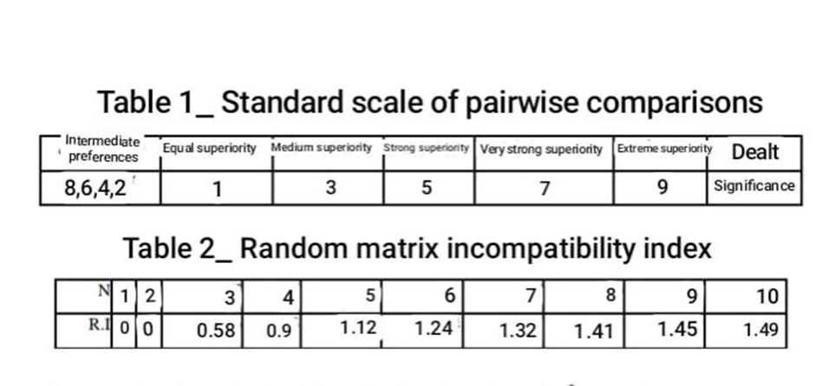
4-In order to improve the set of step 3 matrices, n(n_1) judgment is required, which is obtained automatically in each of the pairwise comparisons.
5-In this step, a hierarchical combination is used to weight specific vectors. For this purpose, weighting operations are performed with the help of standard weights and the sum of all weights of special vectors that enter the next level of the hierarchy.
6-Perform all binary comparisons to determine compatibility, with the help of a special element 8
The compatibility index is calculated as Equation (1): where n means the size of the matrix. Judgment compatibility can also be checked by obtaining the CR incompatibility ratio from C by assigning the random compatibility figures in Table (2). CR is obtained by dividing CI by RI. If the CR value is less than 0.1 or in other words less than 10%, it is acceptable and if it is higher, the judgment matrix will be inconsistent. Judgments need to be reviewed and revised to obtain a consistent matrix. Step 7: Steps 3 to 6 should be done for all levels of the problem hierarchy. Data analysis In this study, to select the most suitable concrete for the construction of tall concrete buildings, the method of hierarchical analysis has been used as an evaluation tool. The hierarchical structure of selecting the most suitable concrete for the construction of tall buildings is presented in Figure (1). Selecting the most appropriate text as the main goal in hierarchical level 1, the criteria and sub-criteria are in level 2 and 3, respectively. In this study, while a case study of a 21-storey building located in Babolsar city, a questionnaire and the results of the questionnaire analysis were used. After selecting the desired options and also selecting the effective criteria in the decision, with the help of experts, which included a group of contractors and consultants of the project and university professors, the criteria were weighed and averaged. Finally, by performing the armor comparisons of the criteria and calculating the rate of incompatibility and controlling the acceptability of each pairwise comparison (Table 8), the relative weight of each criterion and sub-criterion for different options using Export Choice software The criterion was designed using AHP method, which is shown in Table (9). Prioritization of different concretes with and without the need for reinforcement to all the main criteria is presented in Table (10)

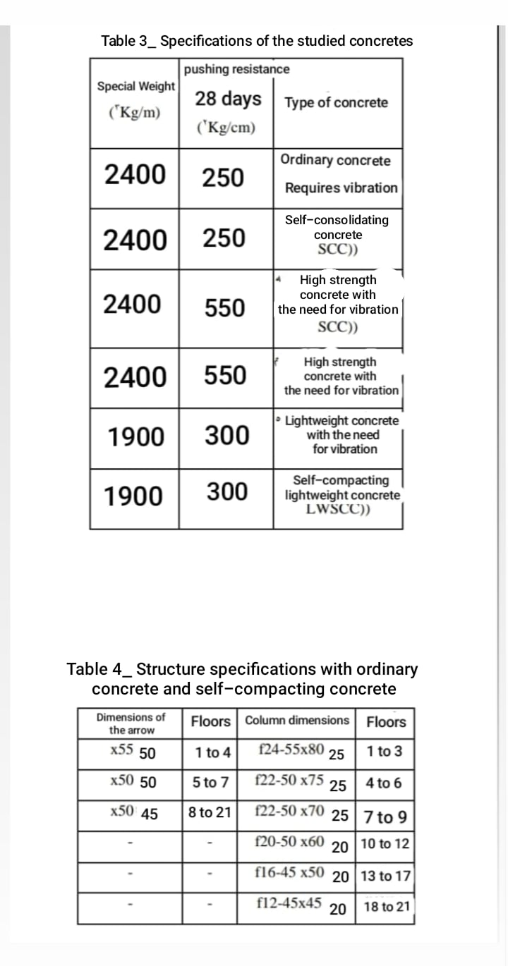
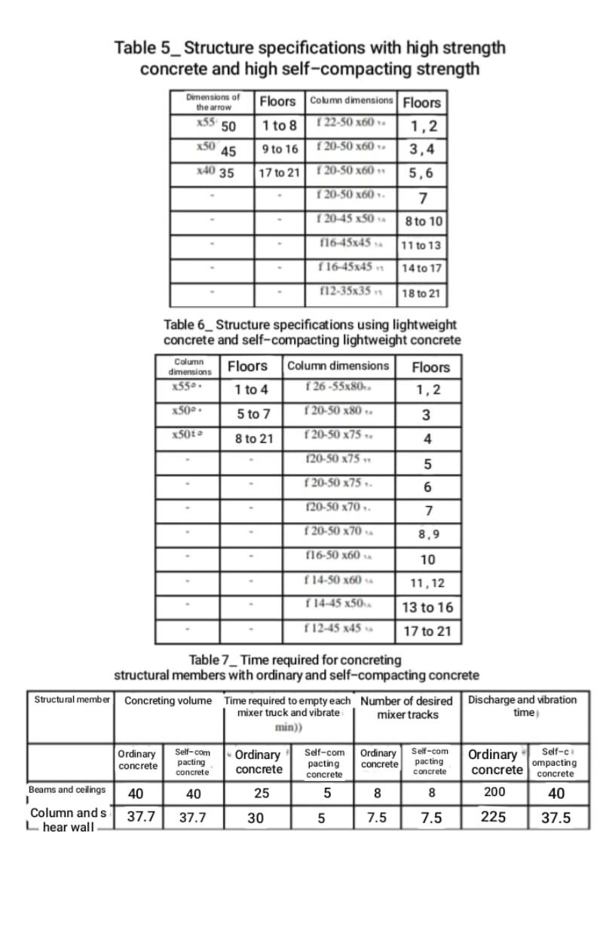
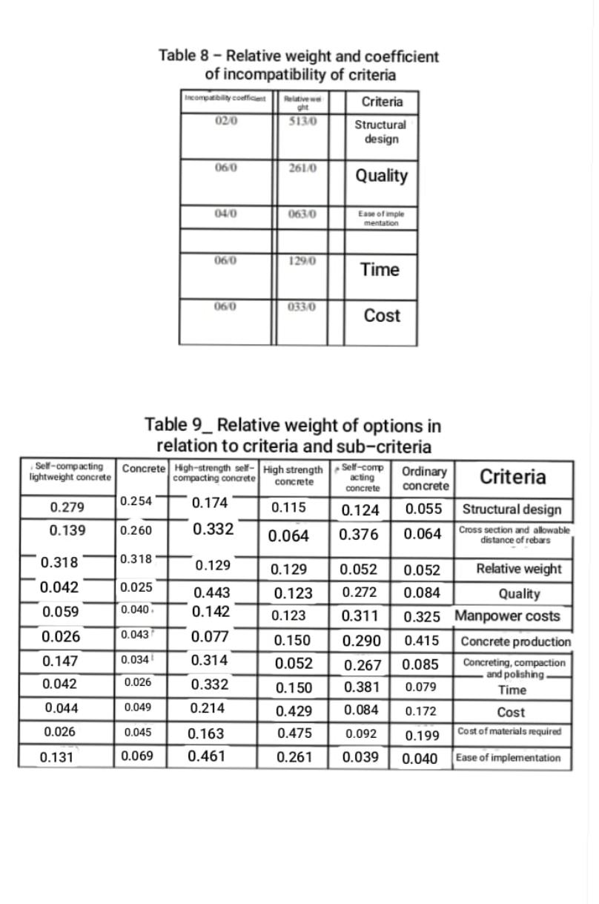
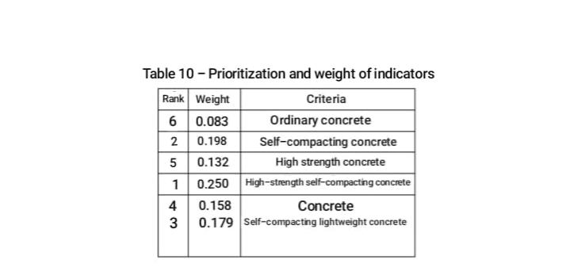
Concrete structures
Concrete structure design is one of the subsets of structural design. The design of a concrete structure is different from the design of a Ferlani structure. Conventional concrete structures have fewer movements than steel structures. Because zero to one hundred concrete structures can be designed with the same design software as Itens, but in mesani steel structures, melen joints, etc. can not be designed with the help of software and requires sufficient experience and knowledge… On the other hand, in many steel structures, the desired answer can be obtained in the field of connection design according to the provisions of the tenth bylaw of the national building regulations.
Tall building design
In the past decades, instrument systems used in tall buildings have included systems such as rigid frames, braced frames, shear walls, or a combination of these systems. But today, new systems such as piping systems, truss belts and diagonal grids have revolutionized tall buildings both architecturally and structurally. Columns and walls in the type of important and common members bear vertical loads. Walls act independently as shear walls or in combination as shear wall cores. The walls divide the spaces and the cores are the place to serve the elevator. On the other hand, the columns, while creating space, can withstand vertical loads and in some structures, horizontal loads.
Columns are sometimes used as architectural tools and building facades. The primary use of vertical members is to withstand heavy loads due to the weight of the structure and its accessories. Because the load of almost all classes is the same. Regardless of the number of floors and the height of the building, the unit weight of each floor area will be almost constant. As the load of the columns increases from top to bottom, the resin of the columns per unit area has an almost linear relationship with the height of the structure. The use of ostrich members of Qom instruments is to withstand the forces caused by wind and earthquakes, the quantity of which is determined by regulations or wind turbidity studies. The bending anchors due to these lateral loads increase in proportion to at least the second power of the structure height. As a result, their effects increase exponentially as the height of the structure increases. Since the occurrence of the worst housing condition due to lateral loads on the structure during its lifetime is very far from expected, it is necessary to achieve the optimal design; Minimize the exponential effects of height.
The constant search for better solutions has led to the designs and forms of fetal instruments in recent years. The forms of new instruments are introduced in the fourth chapter. To create a suitable system that is resistant to lateral loads, the designer will usually find hard drop members to attach to the pen members to create a composite set such as shear walls and frames. These sets, as will be shown in later chapters, create instruments whose lateral stiffness will be several times the sum of the lateral stiffnesses of each member of erect.

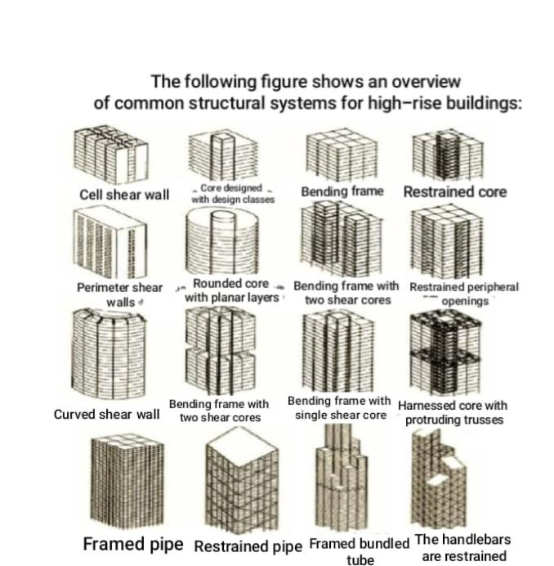

Anchoring system
One of the methods to increase the stiffness and strength of seismic systems located near the central core of the building is their anchoring by horizontal trusses that are installed at different heights.

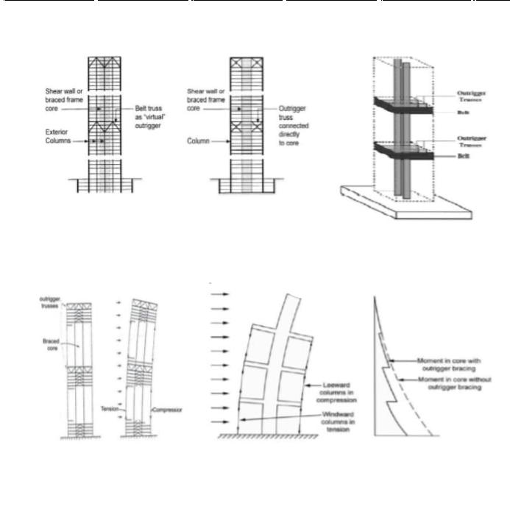

When the structure is placed under lateral load, these trusses cause the columns on one side of the core to be stretched and the other side to be pressed, resulting in the whole structure acting as a beam. In fact, the overturning anchor of the seismic core is transferred by these trusses to columns that do not have much seismic capacity in the absence of these trusses.
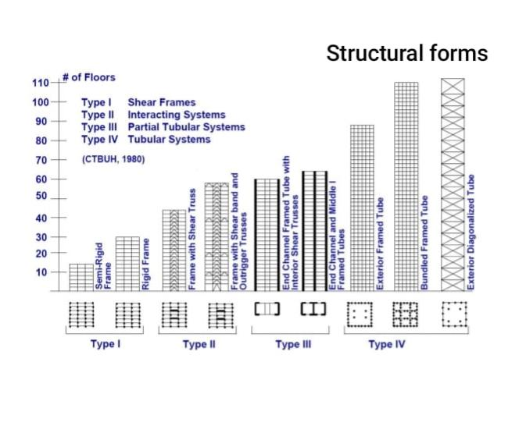

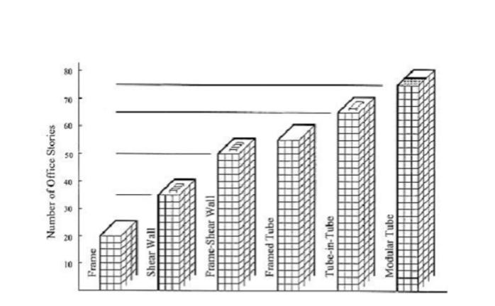

Braced Frame (Structures In braced frames)
the lateral strength of the structure is provided by the diagonal members which together with the beams form the life of a vertical truss system. In this system, the columns are truss wings.
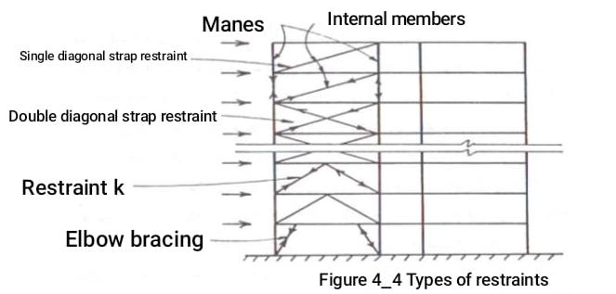

Intermediate frames
Braced Frame Structures In braced frames, the lateral strength of the structure is provided by the diagonal members which together with the beams form the life of a vertical truss system. In this system, the columns are truss wings.
In many countries, mezzanine frames are the most common form of construction for buildings up to 30 storeys high. In this type of structure, reinforced concrete frames and sometimes steel are filled with building materials such as bricks or cement blocks or in-situ concrete.
When a intermediate frame is subjected to a lateral load, the fillers act effectively as compressive members of the diagonal braces (Figure 4-7). Because fillers also work on exterior walls or interior walls, they are an economical system for strengthening and hardening structures.

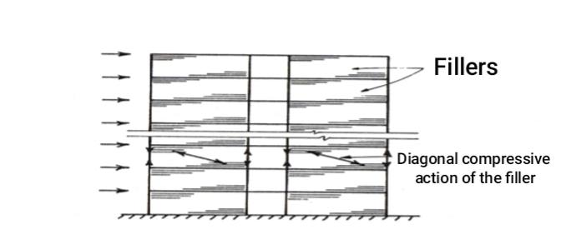

Coupled Shear Walls
Couple walls are a special but common form of shear wall structures that have a special analysis and design method.
has it These structures consist of two or more shear walls in a plate or almost in a plate that are connected to each other at the level of the floors by beams or hard beams (Figure 4-9).
The presence of connecting shear members between the walls creates a plan composed of a set of two or more walls that bend around a common central axis
he does. As a result, the stiffness of the drop will be much higher than if the walls act as independent plans.
• Couple walls are commonly used in a type of residential building in which nationwide walls
They separate the apartments. Global walls consist of two or three shear walls located on a plate with corridors and windows between them.
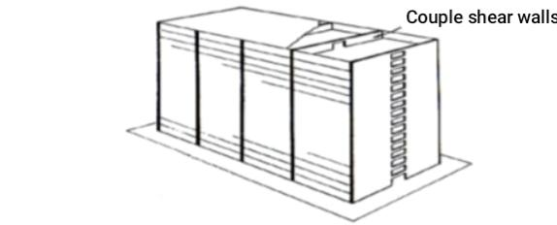
Wall structures
A) Framed frames
Tube Lateral strength of structures with perimeter frame, is provided by very rigid molds that are located in the building environment and form a closed wall. Perimeter frames consist of columns 2 to 4 meters apart that are connected to each other by deep beams (Fig. 1104). Although peripheral contact frames withstand lateral loads, vertical loads are also divided between the perimeter columns and the inner columns. When the structure is subjected to lateral load, the perimeter frames are loaded in the form of souls and the frames perpendicular to the load are
The wings have been shown solely to give a sense of proportion... Peripheral frame structure is one of the most advanced structural forms of tall buildings, which has a good relative efficiency and
Easy to run, suitable for any height.
Although the performance of the perimeter frame structures is very good, it is still possible to modify and complete the system
There is more work to be done because the frames that perform the wing operation seem to have a lame cutting problem. This problem is due to the fact that the middle columns of the wing frames are more stressed than the corner columns of these wings
They are placed less, so not all of their capabilities are used in wing behavior. B) Perforated nested molds with core-skin in - Tube). This structural form consists of an outer perimeter frame or shell and an elevator core with a service passage (Figure 12.4).
The core and shell act together to withstand vertical and lateral loads. In steel structures, the core may consist of restrained frames, while in concrete structures it is a combination of shear walls.
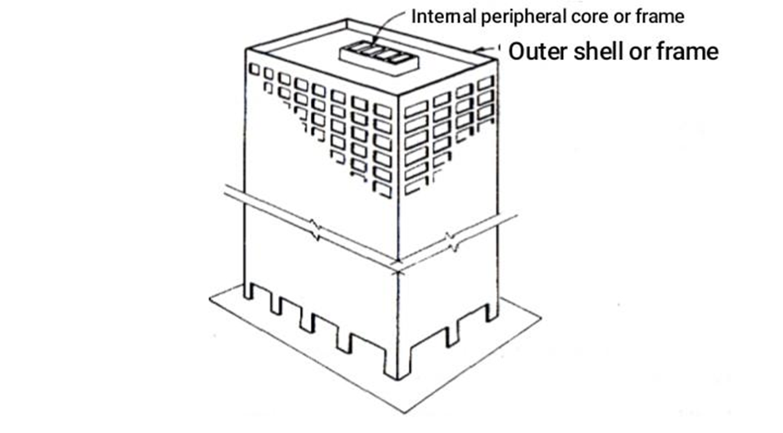

Structures with arm restraint
This structural form has a central core consisting of shear walls with braced frames. The central core is connected to the outer columns by open trusses or beams. To engage perimeter columns that are not directly attached to the arms, all perimeter columns can be connected by one or more belts consisting of trusses or girders at arm alignment. Arm restraint structures have been used for 40- to 70-storey buildings.
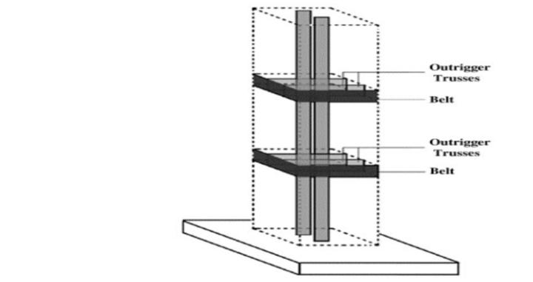

Stability of tall structures
Increasing the height and increasing efficiency of tall building structures, has caused stiffness and thus stability
They are reduced. Now, controlling the effects of reduced stability is one of the most important steps in the design process.
In order to implement the principles of stability, in addition to controlling each of the members of the building, the whole structure
Should be considered as a set. The design related to the stability of single columns is the same for tall and short structures and this is usually.
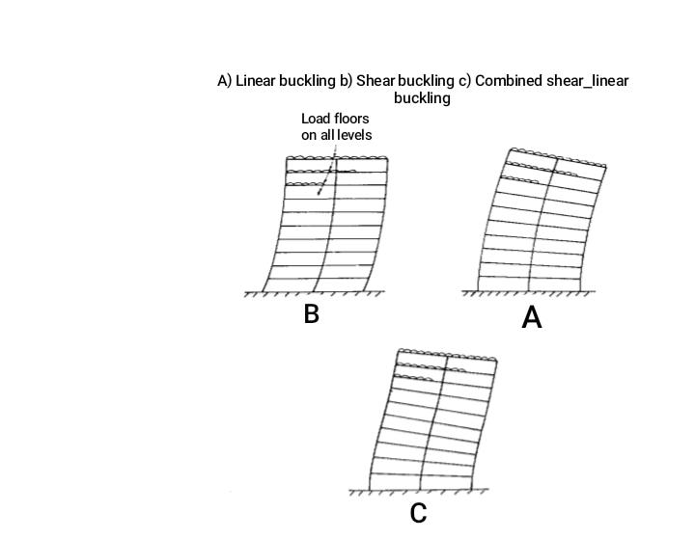

mentioned in the design regulations. Hence, the discussion related to
It will be designed and focused on the whole structure or its floors. . The general behavior of a tall structure is similar to that of a mediocre column. Considering the possibility of flexibility
High or even determinant shear ductility, the behavior of these structures will be different from ordinary structural columns that have a flexural behavior. As a result, the possible modes of general buckling of the structure are not just the bending mode (Figure A), but the shear mode (Figure B), or most likely a combination of both (Figure C). In addition, not only lateral buckling, but also torsional buckling or transverse torsion of the structure also appear.
Total heart rate analysis: Approximate methods
Methods for determining the overall buckling load of the structure are introduced for the following reasons:
1-Determine the upper limit of vertical load
2-Recognition of the relative capability of the building to transverse buckling and torsional perfection
3-Use in approximate analysis and determination of magnification coefficient of displacements and anchors
Shear mode
This buckling mode is generally used in anchor-resistant frames and in the case of floor displacement due to bending in the curvature of the columns.
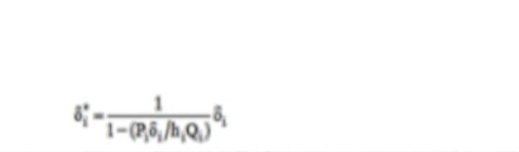
It is famous, it appears. In this approximation method, all the effects of axial deformation of the columns are eliminated. The displacement of the floor of a frame, including the secondary effects of Qatem loading, can be estimated from the following equation:
In this regard, subtitle i represents class i and Oi, the first degree displacement of the floor due to external shear, and Oi and Pi are the vertical loads applied on the floor columns and Bi is the height of the floor
When we have a complete plague, we will have stability, when the denominator of Equation (17) becomes zero. In this case, the displacement will be infinite as a result of:
The result is a critical load in shear mode, as follows

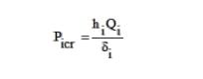
By referring to the books, it can be seen that the lateral stiffness of the floor can be defined as follows

It is related to the sum of columns with moment of inertia 1 and length 8 floors and (G = SIL is related to the set of beams with moment of inertia 1 and length 1 on the upper floor of the floor by replacing the relation

(7-4) in relation (3-7), The critical load of the floor is obtained according to the properties and dimensions of its members

The first floor of the frame needs special attention. If this floor has a rigid connection to the base, its critical load will be calculated from the following equation
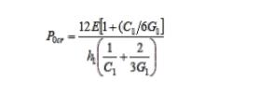

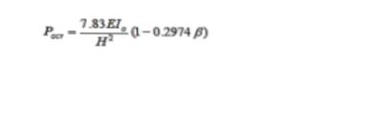
And if it has a joint connection to the foundations, the critical load is obtained from the following equation

2-1-7 Bending mode
In this mode, the whole structure arches like a bending plane by changing the axial shapes of the columns. The thinner the structure, the greater its ability to become unstable in bending mode.
The buckling load is a function of the moment of inertia of the plane and is equal to the second anchor of the Cross sectional surfaces of the columns around their common center. Assuming that, this moment of inertia, in order to calculate the dimensions of the columns in height The frame changes from 10 at the foot of the structure to (-10 at the top of the structure)
Combination of shear and flexural modes For cases where buckling occurs in a combination of flexural and shear hairs, a structural model for vertical buckling under the weight load performed on top of it, and its solution is.

The order are the critical loads of the combined reduction, flexural and shear modes of the model solution in the vertical wide load mode is equal to
They are the critical loads of the lower floor, respectively, for the combined buckling modes, flexural and shear.

This approximation method is proposed for use in the early stages of design and estimation of the importance of the buckling flexural mode compared to the usually prevailing shear mode
(7-2) Analysis of the general decrease of the frame walls
From relations (7-5) to (7-10), the total buckling load of a structure in shear, bending and composition modes can be estimated approximately
A more accurate analysis of frame-wall structures with a symmetrical plan will lead to solving the arcuate loads of frame structures on the one hand and shear wall structures on the other, and will solve the relative composition of hearts and walls.
Analysis method In this method, it is assumed that the properties of the structure are uniform and the load is applied uniformly in the direction of height on the structure (Figure 2016a) by introducing the walls by a bending plane, frames By a shear plane and their connections by a uniformly rigid joint at a height (Fig. 2016b), the equilibrium differential equations can be formulated and the critical buckling load obtained by solving them. Solving these differential equations is available for the usual stiffness ratios of frames and walls. Although the analysis steps are very long and complicated, the calculation of lateral and torsional critical loads using the following method is relatively simple will be
Figure 2_7
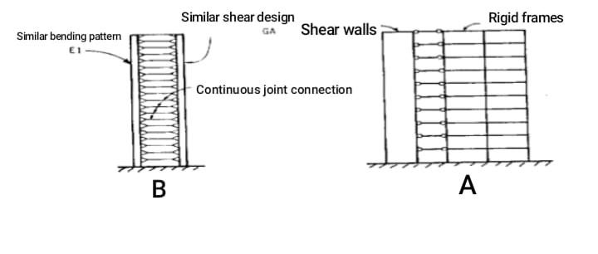
A. The structure of the wall frame is uniform, continuous

Effects of relative movements
The actions caused by creep and alluvial of concrete members depend on the percentage of steel, the volume to surface ratio of the concrete and the properties of its constituent materials. When similar members are subjected to the same stresses, the strain due to creep and alluvial decreases with increasing steel percentage and volume to surface ratio. In tall buildings, adjacent lattice members may have different percentages of steel in terms of different pen loads. As a result, the relative shortening of adjacent columns, due to the relative displacement of the supports, creates cuts and anchors in the connecting beams and pans. By transferring the load to the columns that are less shortened, the load is redistributed. For example, if a large column with a lot of steel is placed next to a shear wall, we will have the problem of redistribution. Shear wall due to lower volume to surface ratio and steel percentage compared to the column, will have more creep strains and alluvium and therefore the column will have to withstand some wall loads. The relative motion at the height of the building is added together, so that they are zero at ground level and maximum at roof level. As a result, the significance of the effects increases with increasing altitude, and the total displacement causes damage to non-structural members, such as partition walls and windows, and creates additional stress in high-level beams. One of the most critical and sensitive parts affected by vertical movements is the facade of the building. In many concrete buildings with a facade consisting of building materials, this issue is predictable
Usually, after the concrete frame creeps, the building materials of the exterior are subjected to compressive forces and loads, followed by buckling, crushing or crumbling of the facade. In some buildings, to relieve the stresses caused by this
The phenomenon is forced to create a horizontal seam in the facade. Design for relative movements
. Information on concrete alluvium, usually through standard sample tests, under controlled conditions
It is prepared in a laboratory. Creep information is generally obtained from samples under constant load. Therefore, in the creep state, due to the fact that in practical conditions, the loads are increasingly increasing through the construction of successive floors, it can not be a direct reference for determining the inelastic behavior of columns in tall buildings. Although creep and alluvium shorten vertical members, execution time and stages have a significant effect on the total creep effect at each level, while the effects of alluvium are independent of execution time. As a result, the stresses caused by creep and alluvium must be calculated separately and then combined
Their effects on the structure of the study. In design, calculations are performed in two steps ١. The amount of displacement due to creep and alluvium in columns and shear walls should be determined based on the loading history, dimensions of the firing members and environmental conditions.
2- Forces created in the members, taking into account the elastic and inelastic shortening of the vertical members
Be calculated. Thermal displacements, because they are elastic in nature and have continuous seasonal and daily changes in
They are the lifespan of structures, different from the inelastic deformations caused by creep and alluvium. Heat
May shorten or lengthen structural members... The members on the sunny side of the building will have a higher temperature than the members on the shady side, and therefore
The building tends to move in the opposite direction to the radiation. According to observations and calculations, in some cases the displacement of radiation above the building can be up to 20% of the displacement caused by wind force. Predictable items to minimize relative movements are: the design of the appropriate mixture for concrete, precise control in the operation of concrete and proper accuracy and supervision in the execution stages of concreting different members. If possible, adjacent columns and walls should have the same percentage of steel and close stresses
The effect of steel on stresses due to creep and alluvium
When a reinforced concrete column is subjected to compressive forces due to creep shortening
And alluvium, stresses are gradually transferred from concrete to steel. In certain cases where the column has a lot of steel, even all the axial loads may be transferred to the steel, and the concrete may be stretched due to alluvial. The transfer of stresses from the concrete may significantly reduce the shortening due to creep and alluvium and, as a result, reduce the relative effects of the applied effects on the beams.
vertical loading
borne by the beams and beams of tall structures are not different from the loads associated with short structures, but the sum of the loads applied to the columns and walls of tall structures is much higher than the loads similar to short structures. Dead load in short structures is calculated using the specific gravity of the designed members. The difference between design sizes and actual sizes and estimated weights with actual values ​​has little effect on the accuracy of the calculation

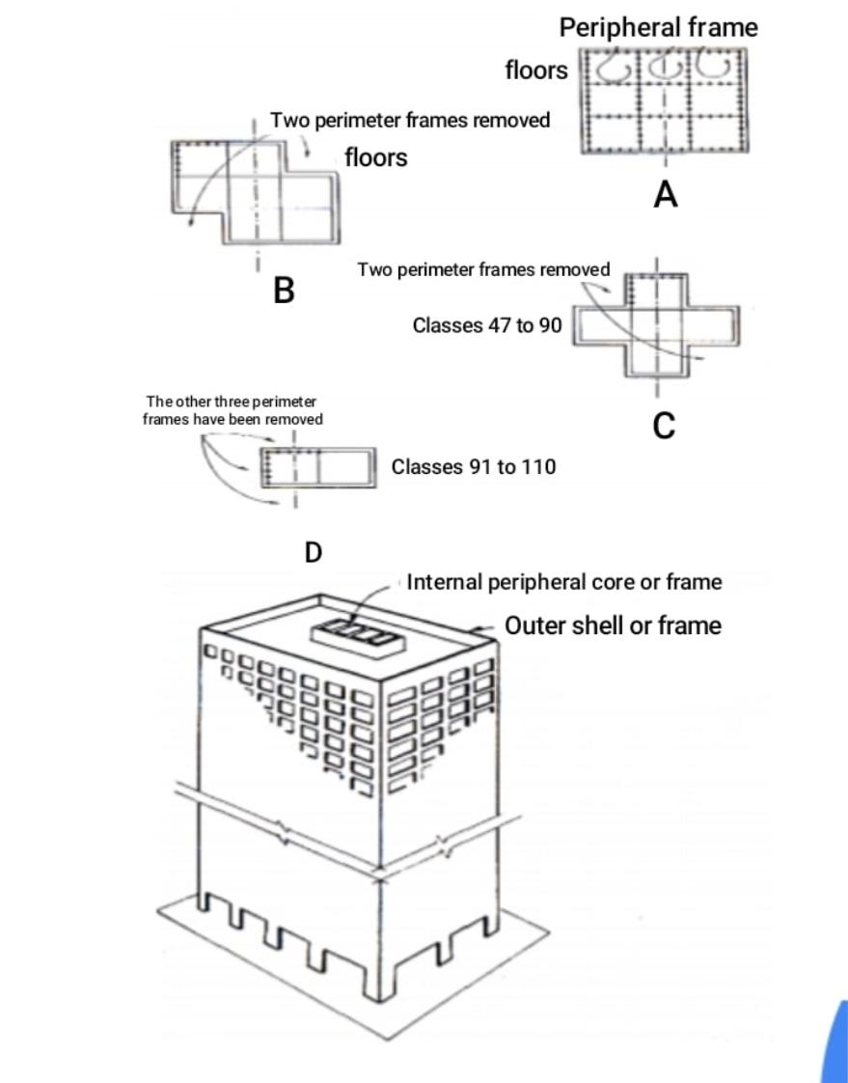

Conclusion
According to the studies performed, all models are upgraded after performance with steel bracing. Models provide the minimum level of life safety performance after retrofitting. This upgrade is the result of controlling the displacement of reinforced concrete. Lateral stiffness due to the use of steel braces in malleable molds increases further. According to the results, the method of reinforcement with steel bracing in tall structures, to control the relative displacement of floors in the allowable range, is relatively weak. According to the results, tall reinforced concrete structures with special bending frame in the maximum probable earthquake (equivalent to 2% in 50 years) are in the range of collapse threshold performance.
From the studies performed on the joints, it seems that the effect of bracing in the period of columns is more than beams, so it can be concluded that this method to strengthen structures with weak columns and strong beams show good performance

Resources
Chi Construction Company
Salman sustainable Development Company
Vista Magazine Information Newspaper
Iran Concrete Clinic
Case study of Babolsar 1st floor project (Ali Akbar Maghsoudi Habibollah Akbarzadeh Bangar Mehrdad Masoudnejad)
Abtin Apadana Engineering Company
Atlas Concrete Company (Ebrahim Mehdizadeh)
Server studio architecture design
Basics of designing high-rise buildings Mahmoud Golabchi Mohammad Reza Golabchi)
University of Tehran Press, Page 4 Numerical analysis of vibration control of tall buildings using a balanced damping mass system (Bemanyan et al.)
Earthquake Engineering (Basics and Application)
Modares Civil Engineering 106 (2011)
Publication of culture
Dehr Arvin Nab Company
Borna News
Analysis and design of tall structures
(Brian Stafford Smith, Alex Cole) _ Translated by Dr. Hassan Haji Kazemi
Tall building structures (Wolf Gang Schuler)۔ Translated by Dr. Hojjatullah Aali Raftar
Structural design of tall buildings (Fariborz Nateghi Elahi, Engineer Reza Kakavand Asadi)
Sturdy structural systems in tall buildings (Dr. Ali Khairuddin, Engineer Sima Aramesh)
Design of tall structures (Musa Hamidi)

